Functional Specification

Year: 2023 Semester: Spring Team: 8 Project: Engineer’s Chess

Creation Date: 1-18-2023 Last Modified: 1-18-2023

Team Members (#1 is Team Leader):

Member 1: Jack Gardel Email: jgardel@purdue.edu

Member 2: Tyson Kline Email: kline62@purdue.edu

Member 3: Andy Helton Email: helton4@purdue.edu

Member 4: Bazim Azeem Email: [bazeem@purdue.edu](mailto:bazeem@purdue.edu)

**Fig 1**: Functional Block Diagram

1.0 Functional Description

This project will be a voice activated chess game. The current state of the chess set will be displayed on a central 64x64 LED matrix. A player will be able to give an input, such as “Alpha-6 to Alpha-7” to the game. A microphone will take the voice input and transmit to a Jetson Nano. The Jetson Nano will use that data to determine what move is being requested, then send that data to the STM32 microcontroller. Programmed logic will determine whether the inputted move is legal, then display feedback through two mirrored LCD text displays. There will be multiple buttons to control the flow of the game such as undo buttons and reset buttons. There will also be a settable game timer to optionally be used during the game, that will be displayed on the feedback LCDs. When this project is complete two players should be able to play a complete game of chess using only their voices to control the pieces. The PCB will be powered through a barrel jack, that will then send 5V to the Jetson Nano. Regulators will then be used to convert the voltage to 3.3V to power the STM32 microcontroller and the LCD text displays.

2.0 Theory of Operation

Engineer’s Chess has high computational requirements for voice recognition, the first part of which is creating a spectrogram. A spectrogram stores the frequency information of the incoming speech data at increasing intervals of time. The frequencies at the individual time intervals are calculated using a discrete fourier transform (DFT). Let the time-domain signal of length N be denoted $x\left(n\right)$ and the DFT of the signal be denoted $X\left(k\right)$. The relationship between the two is

$$X\left(k\right)=\sum_{n=0}^{N-1}{x\left(n\right)e^{-j\frac{2πk}{N}n}}$$

And the inverse relationship being

$$x\left(n\right)=\frac{1}{N}\sum_{k=0}^{N-1}{X\left(k\right)e^{j\frac{2πk}{N}n}}$$

From the inverse relationship, we observe that $x\left(n\right)$ is decomposed as a bunch of sinusoids at different frequencies, and $X\left(k\right)$ are the amplitudes at those frequencies that tell us the layout of the frequency domain. A value $k$ corresponds to digital frequency $\frac{2πk}{N}.$ This operation is carried out at predetermined intervals of time, where $X_{i}\left(k\right)$ is computed at times $n_{i}→n_{i}+N$. Each $X_{i}\left(k\right)$ is treated as a row in the spectrogram matrix. Moving between rows results in a change in time, and thus the frequency spectrums of different syllables in a word. The following spectrogram is for the sentence “The rainbow was seen after the rainstorm”:

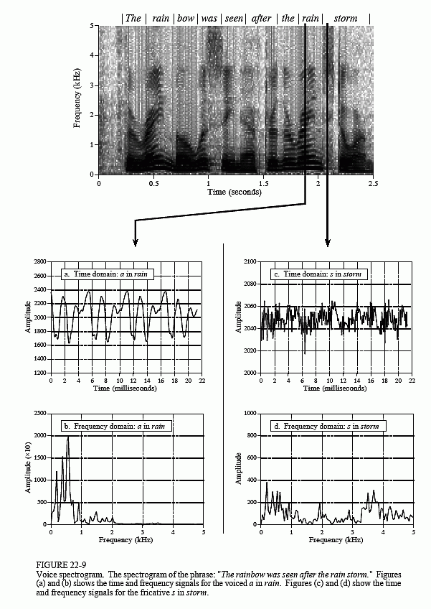

Fig 2: Spectrogram for the sentence “The rainbow was seen after the rainstorm” - from Smith [1]

Seen above, the frequencies can be observed for each syllable and sound individually, allowing us to assemble each spectrum into full words and phrases. After the spectrogram is made, it is sent piecewise to a chosen classification algorithm trained on lots of speech data.

3.0 Expected Usage Case

The Engineer’s chess board is designed to be used on a stable, stationary surface, such as a table. After a game is played, the board and power source can be stowed away.

The board also requires electrical power, so there must be a nearby electrical outlet. Furthermore, basic precautions against electrical hazards are expected to be taken by the users. For example, do not place the board somewhere that could get wet.

The device is designed to be used by two players. The users should have sufficient physical mobility to press the buttons. If not, a third person may be required to assist in these actions. The users are also expected to be able to speak (or use an alternative, such as text to speech) so the board can receive commands. It will be helpful if the environment is relatively quiet.

Our target customers for Engineer’s Chess are hobbyist who enjoy board games and technology. We additionally are targeting stores that would attempt to sell this board, thus regulations for these organizations will need to be met.

4.0 Design Constraints

4.1 Computational Constraints

One timing requirement includes the ability to refresh the LED matrix quickly enough, such that it appears to be a solid display. Additional memory constraints include the need to store game data and the colors for the display.

The computer in charge of signal processing and speech recognition must be fast enough to simultaneously support a fast-fourier transform algorithm, as well as a classification algorithm such as Naive Bayes or k-nearest neighbor, paired with additional algorithms for construction such as hidden Markov models. With these classification algorithms comes the need to store training data and incoming speech data, which has a significant demand for both volatile and non-volatile storage.

4.2 Electronics Constraints

Engineer’s Chess will have two LCD displays, one for each player. It will display the board on a 64x64 LED matrix. The voice input will require a microphone, which in turn will be connected to a separate but integrated computer for speech processing. Several buttons will be used to control various aspects of the game, and a simple power switch will be used to power the game on and off. A game-command protocol will need to be established between the secondary speech-processing computer and the microcontroller so that the secondary computer can tell the microcontroller what command it heard.

|  |  |  |  |
| --- | --- | --- | --- |
| **Device** | **Voltage (volts)** | **Current (mA)** | **Power (mW)** |
| LCD display | 3.3 | 24 | 79.3 |
| 64x64 LED matrix | 5 | 1560 | 7800 |
| Microcontroller | 3.3 | 120 | 396 |
| Secondary computer | 5 | 1000 | 5000 |

4.3 Thermal/Power Constraints

This project is meant to be connected to an electrical outlet to receive power when in use. Therefore, power consumption is not a significant concern. The hardware for this project is designed to be air-cooled and there will be no dedicated cooling solution. We do not expect the device temperature to exceed 50°C. We also do not expect temperatures to dip below 0°C, which may cause damage to the LCD display [4]. The expected use case for this device is at room temperature.

4.4 Mechanical Constraints

In terms of size, we expect our project to be similarly sized to a normal chess board. The weight is also relatively similar to a normal wooden chess board. Because the board is meant to remain stationary while in use, the size and weight are not a big constraint on this project.

The board is not designed to survive a high drop or any significant impact. Furthermore, the board will not be waterproof or dust-resistant. Therefore, we expect the users to follow basic procedures against damage from these sources.

4.5 Economic Constraints

There will be a large degree of freedom in terms of cost of the project. A simple, decent quality chess set will typically cost about $10 - $20 dollars, but the draw of Engineer’s Chess will not be its cost - it will be its unique method of playing the game. This draw will overcome the higher cost, and make the product competitive with other electronic or novelty chess sets. These types of chess sets often cost several hundred dollars. For example, the DGT Smart Board - Electronic Interface Chess Set has a cost of $495.00 [2]. Another example, the Metal Chess Set with 3D-Theme costs $325.00 [3]. The final cost of Engineer’s chess should fall somewhere near this range, or between $300 to $600.

5.0 Sources Cited:

* [1] Steven W. Smith, “Chapter 22: Audio Processing” in *The Scientist and Engineer’s Guide to Digital Signal Processing* San Diego, CA, United States, California Technical Publishing, 1997, ch. 22
* [2] “DGT Smart Board - Electronic Interface Chess Set,” *Chess House*. [Online]. Available: https://www.chesshouse.com/products/dgt-smartboard?msclkid=adccfeb8298815c822069d7076542465&utm_source=bing&utm_medium=cpc&utm_campaign=0.1+AMG+Shopping+051419&utm_term=4577473068832057&utm_content=All+Products. [Accessed: 18-Jan-2023].
* [3] “Metal chess set with 3D-theme decorative: Egyptian,” *G8Central*. [Online]. Available: https://g8central.com/products/metal-collectible-chess-set-egyptian?variant=39392136724576&utm_medium=cpc&utm_source=bing&utm_campaign=Bing%2BShopping. [Accessed: 18-Jan-2023].
* [4] Selecting LCD Modules for Extreme Temperatures | DigiKey, by Gina Roos (2014).

Available: <https://www.digikey.com/en/articles/selecting-lcd-modules-for-extreme-temperatures>